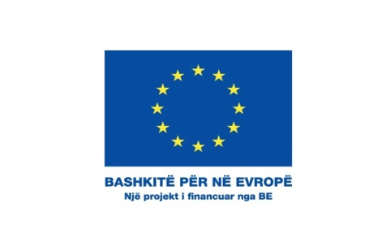

Erasmus Plus “Capacity Building in the Field of Youth” 2018 – CALL FOR PROPOSALS
Call | Erasmus+ - Key Action 2 - Capacity Building in the field of youth
Deadline | 08.03.2018
Budget | 150.000 Euro
Link | https://eacea.ec.europa.eu/erasmus-plus/funding/capacity-building-in-field-youth-2018_en
Call`s objective | Capacity-building projects in the field of youth cover a range of activities that encourage cooperation between organisations active in youth, education, training and other socio-economic sectors
Eligible actions | Promote cooperation between:  - youth organisations and public authorities in Partner Countries  - youth organisations in education and training and the business and labour market  - Strengthen youth councils, youth platforms and authorities in Partner Countries (local, regional, national)  - Support the overall operation of youth organisations in Partner Countries  Help implement youth work practices which include:  - tools for the development of youth works and trainers,  - non-formal learning methods to improve skills,  - new training schemes, flexible learning, virtual mobility and better ICT  - peer learning activities to improve the leadership of youth organisations
Who can apply | - non-profit organisations, association, NGO (including European Youth NGOs)  - national Youth Councils  - a public body at local, regional or national level  - a school/institute/educational centre (at any level, from pre-school to upper secondary education, and including vocational education and adult education);  - a public or private, a small, medium or large enterprise (including social enterprises)  - a social partner or other representative of working life, including chambers of commerce  - craft/professional associations and trade unions  - a higher education institution  - a research institute  - a foundation  - an inter-company training centre  - a cultural organisation, library, museum  - a body providing professional counselling and information services.  Consortium :  Capacity-building projects require the participation of 3 organisations from 3 different countries (at least one from a Programme Country and at least one from an eligible Partner Country).

